Science Engagement Programme

Communication
Package

E-mail (with attached calls)
Dear Colleagues,
The British Council is pleased to announce a call for early career researchers to apply for the two online training programmes:
- Online Science Communication and Public Engagement Training Programme - Training programme aims to improve the capabilities of early career researchers to effectively communicate science and engage with wider public. It is for early career researchers (someone who is within eight years of the award of the PhD) from all disciplines. The programme will be delivered in cooperation with the University of West England (Bristol) and the ThinkWrite organisation. For more about the training programme see attached documents.
- Online Policy Engagement Training Programme - Training programme aims to improve the capabilities of early career researchers to translate scientific evidence into policy and more effectively engage with policy makers and other stakeholders. Training programme is for early career researchers (someone who is within eight years of the award of the PhD) who are doing research in the following areas: health, social care, education, environment, agriculture, energy, disaster risk management, economy, etc. The programme will be delivered in cooperation with the Dods Parliamentary Communications. For more about the training programme see attached documents.
Deadline for the submission of applications is Tuesday, December 1, by 23 h (CET).

Web page
The British Council is pleased to announce a call for early career researchers to apply for the two online training programmes:
- Online Science Communication and Public Engagement Training Programme - Training programme aims to improve the capabilities of early career researchers to effectively communicate science and engage with wider public. It is for early career researchers (someone who is within eight years of the award of the PhD) from all disciplines. The programme will be delivered in cooperation with the University of West England (Bristol) and the ThinkWrite organisation. For more about the training programme click here.
- Online Policy Engagement Training Programme - Training programme aims to improve the capabilities of early career researchers to translate scientific evidence into policy and more effectively engage with policy makers and other stakeholders. Training programme is for early career researchers (someone who is within eight years of the award of the PhD) who are doing research in the following areas: health, social care, education, environment, agriculture, energy, disaster risk management, economy, etc. The programme will be delivered in cooperation with the Dods Parliamentary Communications. For more about the training programme click here.
Deadline for the submission of applications is Tuesday, December 1, by 23 h (CET).
Social media
The British Council is calling early career researchers to apply for the two online training programmes: Online Science Communication and Public Engagement Training Programme and Online Policy Engagement Training Programme. For more information click here.

Facebook: @BritishCouncilBosniaandHerzegovina
Twitter: @baBritish

PHOTOS

Web
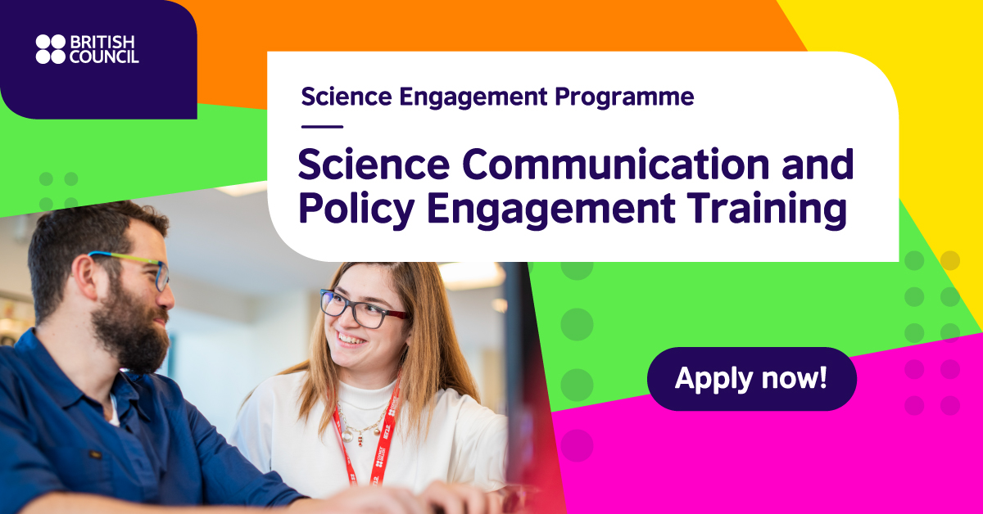

Facebook

Tweeter
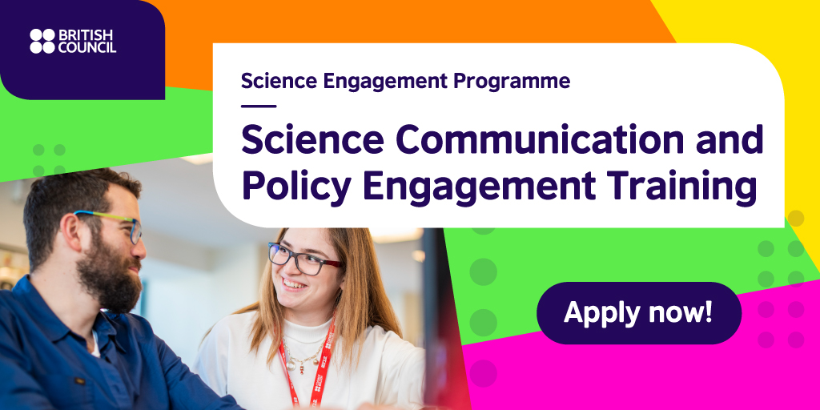

Instagram
